Your Viva Voce or Doctoral Defence: Tips, Strategies and Best Practices

A Webinar

Presented by

Professor Dan Remenyi

Wednesday 3 May 2023

This webinar is designed to prepare doctoral candidates with the necessary knowledge and skills for a successful defence of their doctoral dissertation. It will also increase doctoral candidates’ confidence in coping with this all-important examination.

It covers various aspects of the viva voce or defence process, including issues relating to selecting a committee, preparing for the viva voce examination, the role of presentation skills, and successfully answering questions from the committee. Participants will learn how to present their research, respond to critiques, and demonstrate their expertise in their field of study confidently and effectively. The doctoral defence is a significant milestone in the academic journey of any doctoral candidate. It is a rigorous process that tests the candidate's knowledge and expertise in their chosen field of study.

Participants will learn about the importance of reviewing and organizing their research, developing an effective presentation, and anticipating and preparing for potential questions from the committee. They will also learn about the common mistakes to avoid during the defence and strategies for overcoming nervousness and anxiety.

Participants will learn about the different types of questions they may encounter and strategies for answering them effectively. They will also learn about the importance of active listening and responding to critiques in a professional and respectful manner.

***Webinar outline***

***The date of examination and the examiners?***

What to expect:

* Two or more examiners
* A few months to prepare
* Examiner etiquette.

***Opening statement***

* The importance of the opening statement
* What to include and what not to include

***The dialogue***

Uniqueness of this examination:

* Understanding the nature of the dialogue between the degree candidate and the examiners
* What questions will be asked?
* How to answer the questions.
* What questions might be asked which the candidate can’t answer and how to handle them
* A checklist will be supplied.

***The outcome of the viva voce or defence***

* Pass with or without honours
* Revisions, major or minor changes
* Fail.

***Coping with revisions***

* Establishing the post examination work required
* Resubmission.

***What to do if you fail.***

* The options are available to the student.

The webinar will be held on Wednesday 3 May 2023 from 2:00pm-3:30pm (GMT+1) via Zoom. The Zoom Room will open at 1:45 pm (GMT)+1.

The cost of attending this webinar is £40 per participant. To book a place, visit <https://shop.academic-conferences.org/?ec_store=webinars>

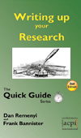Fees include a PDF copy of Writing up your Research by Dan Remenyi which may be viewed at: <https://www.academic-bookshop.com/ourshop/prod_1778325-Writing-up-your-Research-The-Quick-Guide-2nd-Edition.html>

For questions about the webinar contact [dan.remenyi@academic-publishing.org](mailto:dan.remenyi@academic-publishing.org)

**A certificate of attendance can be supplied on request.**

Webinar Facilitator

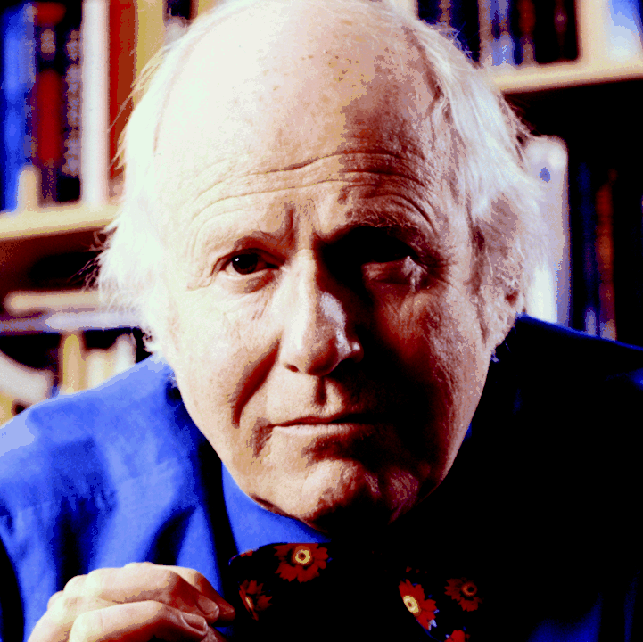**Dr Dan Remenyi** specialises in research methodology. He was for more than a decade a Visiting Professor in Information Systems Management at the School of Systems and Data Studies at Trinity College, University of Dublin. He teaches Research Methodology and Sociology of Research as well as supervising academic researchers and working extensively with research candidates and their supervisors at both doctoral and masters level. He has authored or co-authored more than 30 books and some 50 academically refereed papers. He is published in all 4 of the ‘A’ rated Journals in the United Kingdom in Information Systems Management. Some of his books have been translated into Chinese, Japanese and Romanian. He holds a B Soc Sc, an MBA and a PhD.