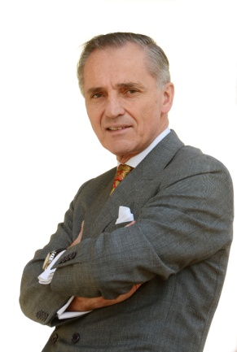

Dr Paul Griffiths BSc, MEng, DBA, A.Dip.C is Professor of Banking, Finance and Fintech and Academic Director of the MSc in Banking and Fintech at the Ecole de Management de Normandie and is based at the UK Campus in Oxford. Prior to becoming a full-time academic Paul spent many years in leadership positions at global management consulting firms, serving Boards of blue-chip companies, particularly in the financial services sector. He specialises in the management of intangible assets such as intellectual capital and artificial intelligence. He helps organisations and industry sectors set up knowledge networks on technological platforms such as cognitive computing, augmented reality and blockchain. Having lived in nine and worked in 15 countries he defines himself as multicultural.

